Technical Report

Interface 2
Comments from milestone 1 3
Unit testing 4
Packaging, deployment requirements and procedure of the system 5

Interface
Our game is a graphics and multimedia user interface application as many other games are.

The interface type of our game is like a graphical user interface: GUI, because it contains a menu and the mouse: the mouse is used by clicking and hovering, to for example close the menu and play the game using the cards by dragging them onto the board/level. The icons in this GUI that represent objects are not really icons but more like sprites for the game, and the key point is to have an interactive GUI so that the game can be played well.

It also falls into the Multimedia interface since the game uses graphical visualisations for almost everything in combination with animations and text explaining the different actions on the cards for example.

(The game is played on the computer, not necessarily on a mobile phone, however sometimes godot seems to be used to play games on a smartphone, in that case the interface may be working as a mobile type too.)

Comments from Milestone 1
A comment that was received after the milestone 1 presentation was to present our UML diagrams in the powerpoint. That made sense, because an improvement will then be the pictures that will explain the system, since the code that we showed instead will not give an easily understandable overview of the game system.

Unit testing
We decided to use Unit Testing as a development testing procedure. We found a third-party library/addon for Godot called GUT.

Unit Test coverage:
- Card
- Deck
- Health Component
System testing coverage:
- Movement:
- Card hand
- Card playing

For the unit tests we tested every method/ function in the classes. For the system testing we simply tested the game by playing it ( game testing). Here we tested if it were possible to actually play the cards from the hand and test if we were able to move outside the playing field or not. We also tested the movement/ level by giving it different movement patterns/ directions that we knew would have to result in an impossible move.

Pictures of some passed tests:
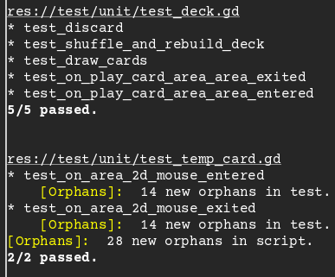
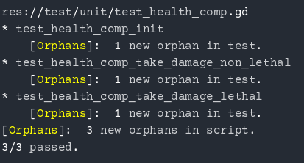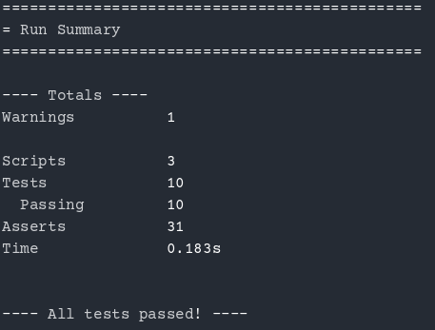

Packaging, deployment requirements and procedure of the system
Godot engine provides support for building for a number of platforms (Windows, Android etc)

To make a game build one would need to have Godot Engine executable and game source code downloaded locally.Then one should follow official Godot documentation

Compatibility on Windows machines: yes. Godot 4.3 should be installed to play the game that we could package in a zip file if not cloning from our github with github desktop.

